THE ENTERPRISE MANUFACTURER LIMITED HUMAN RESOURCE ANALYSIS REPORT
Introduction: The Enterprise Manufacturer Limited is expanding to different locations and wants to better understand its hiring patterns, improve diversity, and ensure equal opportunities for everyone across all departments.
In this report, I will be giving out various analysis within the workforce such as employees demographics, gender and racial distribution when it comes to hiring and the hiring trends over time

Source of data: Kaggle.com.

Data Overview
Dataset Fields
- Id
- First_Name, Last_Name
- Birthdate
- Gender
- Race
- Department
- Jobtitle
- Location
- Hire_Date
- Termdate
- Location_City
- Location_State

There were 2 Locations, 77 Cities and 7 States.

Objectives:
- What is the demographic breakdown of employees across different departments and locations?
- Are there any observable trends in hiring based on gender and race?
- How do hiring trends vary by department and location?
- Which departments or locations demonstrate the most/least diversity?
- What is the average age and experience of employees being hired into different departments?

Data cleaning process
- I used the cleaned dataset of Enterprise Manufacturer Limited Human Resources, but I changed the headers “Location_City” and “Location_State” to “City” and “State,” respectively.
- I added an “Age” column using the “Birthdate” column with the DATEDIFF function in the formula bar because I needed it for the analysis.
- I also added a “Hire Year” column from the “Hire_Date” column using the YEAR function.

Analysis

- Demographic Breakdown Across Departments and Locations.
- There are 22,000 total employes of which 11,000 are male and 10,000 are female among which 42 years is the average age.
- 6328 of the employees are White, total of employees with two or more races are 3648, total employees of Black or African American is 3619, there is a total number of 3562 Asian employees, there is a total number of 2501 Hispanic or Latino employees, there is a total number of 1327 American Indian or Alaska native employees, there is a total number of 1229 Hawaiian employees.
- 16,715 employees works at the headquarters while 5499 works remotely.
- There are 13 departments in the organization and engineering has the highest numbers of employees, and the auditing department has the lowest numbers of employees.

- Identifying hiring patterns based on gender and race.
- The company started hiring in 2000 and recorded its lowest number of hires that year, with 220 employees. From 2001 to 2020, the company maintained a steady hiring rate of over 1,000 employees each year.
- The White race had the highest number of hires, followed by people of two or more races. The Native Hawaiians and Asians had the lowest number of hires each year, while the other races were fairly balanced.
- The Engineering department had the most hires each year, closely followed by the Accounting department. The Auditing department had the fewest hires each year.
- There were more male employees than female employees across all departments and races.

- Diversity Analysis by Department and Location.
- In this analysis, the Ohio State has the highest total number of employees of 18025 while Wisconsin has the lowest total number of employees of 382.
- In all departments present in the Enterprise, the male gender dominates over the female gender and overtime, the Enterprise has hired more males than the females, only in the year 2001 and 2016 that the females were more hired than the males.
- Also, the Auditing, Legal, Product Management and Marketing department has a very low representation which could lead to recruiting more hands to carry out the job efficiently.

- Identifying diversity in department and location
- In this analysis, the male gender has more hands than the female gender, departmentally.
- The headquarters has more racial support than the remote areas.
- The White race dominated most department followed by Two or More races while American Indian and Native Hawaiian has lower departmental engagement.

- Age and experience analysis.
- The Support department has the highest level of experienced personnel while the Marketing department has the lowest level of experienced personnel.
- The VP of Training and Development role has the highest level of experienced personnel in the Enterprise, while the Marketing Assistant role has the lowest level of experienced personnel.

- The Non-Conforming gender has more experienced personnel than the male and the female gender.

Insights: The amount of employees that works at the headquarters are much than those that works remotely.
- There is a higher number of white employees than the other races

- The White race is the race with the most hires in the states.
- The Auditing, Legal, Product Management and Marketing department has very low representation which could lead to recruiting more hands to carry out the job efficiently.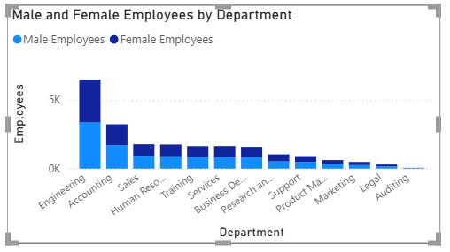

- Ohio has a higher number of employees than the other states.
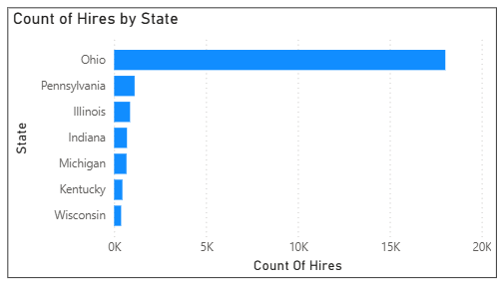

Recommendations:
- The Enterprise should give more job opportunities to other races other than the White race.
- The Enterprise should employ more females than male so as to ensure gender balance.
- The Enterprise should employ well trained younger personnel and retire the older ones so as to encourage as the productivity of the company as it steps forward.
- The Enterprise should strengthening the workforce in other states apart from Ohio.

Conclusion:
This report aimed to provide data-driven insights into workforce composition, hiring trends, and diversity patterns across departments and locations.
Demographics: Overall employee base shows semi-balanced gender representation but uneven racial distribution across certain departments.
Age & Experience: There is a balanced number of employees from the 24-59 age group
Diversity by Location: Ohio has a significant hire number of employees than the others.

Summary
This analysis provided a comprehensive review of the Enterprise’s workforce demographics, diversity distribution, and hiring trends. The goal was to understand the current state of diversity across departments and locations, assess hiring patterns, and identify areas for improvement.

